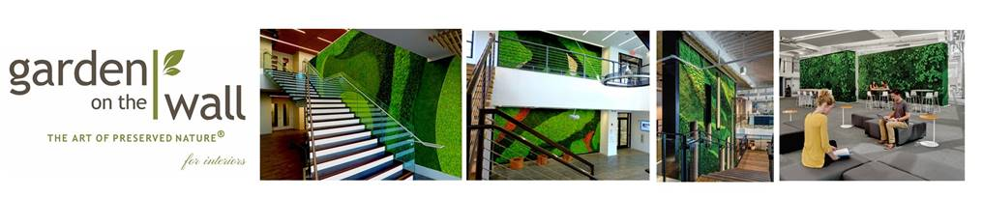
March 14, 2019
Garden on the Wall® to Exhibit at HD Expo 2019
Fairfield, NJ – Garden on the Wall (GOTW) announced today that the award-winning firm will be exhibiting at Hospitality Design Expo at the Mandalay Bay Convention Center in Las Vegas, Nevada between May 15th and 17th. GOTW invites HD Expo attendees to expand the imagination as we bring the outside to inside at Booth #3669. Learn why this Interior Design Best of Year 2018-winning firm has a growing list of Fortune 500 clients and is the preferred partner of the leading architectural firms in the US. Immerse yourself in The Art of Preserved Nature®, and see how GOTW’s unique, turn-key, maintenance-free indoor gardens and modular installations are the ultimate expression of green living.
GOTW’s Largest Indoor Garden Booth Display Is a Must-See!
The GOTW display at HD Expo is larger than ever, going beyond both physical boundaries as well as the boundaries of the imagination. “Las Vegas invites grander and more spectacular displays,” says GOTW’s Mine Hisim, Managing Partner. “This year at HD Expo, our display will take your breath away.” GOTW’s maintenance-free indoor preserved garden is one of many potential incarnations of biophilia that strike a harmonious chord and make perfect sense in the hospitality space.
GOTW is actively welcoming new hospitality projects and is eager to discuss the most ambitious plans of designers with biophilic aspirations, and making their wildest visions come to life… indoors.
Our Commitment to Sustainable Design
Sustainability and biophilia go hand-in-hand, practically and spiritually. Both are philosophies that endeavor to create a symbiosis between humans and nature, for the betterment of both. GOTW aims to play a role in creating spaces that enliven the spirit, imbue peace and a sense of wellness, and also form a natural indoor environment that is lasting and enduring.
Sustainability is important to all of us as a community, and it is at the heart of GOTW’s core beliefs and the founders’ vision. From plant harvesting to fabrication materials and installation processes, GOTW is committed to sustainable practice and leaving behind no footprint… every step of the way.
GOTW is the only preserved garden supplier with the following sustainability credentials:
- A published Health Product Declaration (HPD)
- Numerous credit contributions for LEED® v4 projects (BD+C, ID+C, O+M)
- Installation features that conform to requirements within the WELL Building Standard™ and fitwel®
- The first wall garden system listed in the mindful MATERIALS (mM) database.
- Installation features that conform to the Healthy Hospital Initiative (HHI)

About Garden on the Wall
Garden on the Wall® is an award-winning provider of turn-key, maintenance-free garden installations created with all natural preserved plants. Our gardens require no water, sunlight, or soil and retain their vibrant look for 7-10 years. Our gardens are the idyllic fulfilment of biophilic aspirations for any interior space.

For More Information
Miné Hisim, CSI
Managing Partner
Direct: 1-973-567-6800 ext.101
Cell: 201-463-3647
mine@gardenonthewall.com
www.gardenonthewall.com

